Jesse Carrasco

University of California, Los Angeles

Solid-State Diffusion of Dinosaur Eggshells from Korea

**Abstract**

The stable isotopic composition of dinosaurs eggshells and soil calcites from South Korea have been analyzed to determine the body temperature of these dinosaurs. Carbonate clumped thermometry is a recently new paleotemperature based on measuring the order of  13C and 18O into bonds with each other which makes a 13C18O16O2-2 ion. With well perserved eggshells, the analysis will be able to give a possible body temperature of the dinosaur. However, the eggshells analyzed are not well perserved leading to the discussion of what type of alteration can best explain the data.

**1. Introduction**

Form the most part, the assumption has been that dinosaurs were ectothermic similar to “cold-blooded” reptiles, which derive their heat from the environment. However, there have been many studies, like the one conducted by Robert Eagle (2), that have brought forth the possibility that dinosaurs could be more similar to endothermic “warm-blooded” mammals which are able to regulate their body temperatures internally. In fact, certain records such as behavior, paleogeographic distribution, and anatomy of non-avian dinosaurs, can be better explained if the dinosaurs where endothermic creatures (Eagle 2011). The debate has sparked various studies in order to better understand dinosaur thermoregulation.

Carbonate-clumped thermometry is one of the many methods that have been developed to determine probable body temperature of dinosaurs, and thus predict the dinosaurs’ metabolism. The main focus of this research was to use this method on eggshells are thought to be well preserved, and hope to yield probable body temperature of the dinosaurs. Even though this site has produced plenty of eggshells, little to no data can be found on the crystallization temperature. Large assumptions have been made that the crystallization temperature is about 25º ± 5º C, which are similar to predicted body and environmental temperatures (Kim 2007). However, these numbers are mostly assumption, and not through any thermometry. Thus, this research hopes to calculate a temperature that can be a probable body temperature, and maybe even show a temperature that shows that these dinosaurs could be endothermic, around 37º C.

**2. Geological Setting**

I must first acknowledge that I was not the one that collected the eggshells. The eggshells were donated to Dr. Rob Eagle in order to be analyzed.

The eggshells analyzed are from Upper Cretaceous Seonso Formation, from Korea. This formation is a fluvial and lacustrine assemble that has provided more than two hundred partially to well-preserved sauropod and ornithopod eggshells (Paik 2005). As seen in figure 1, many eggshells have been analyzed in published papers and have yielded data that show promising data. There seams to be two distinct regions for calcites and eggshells. The sediment is mainly consist of conglomerates, pebbly sandstones, sandstones, and mudstones (Kim 2007). There are also plenty of pebbles consisting of igneous and volcanic fragments.

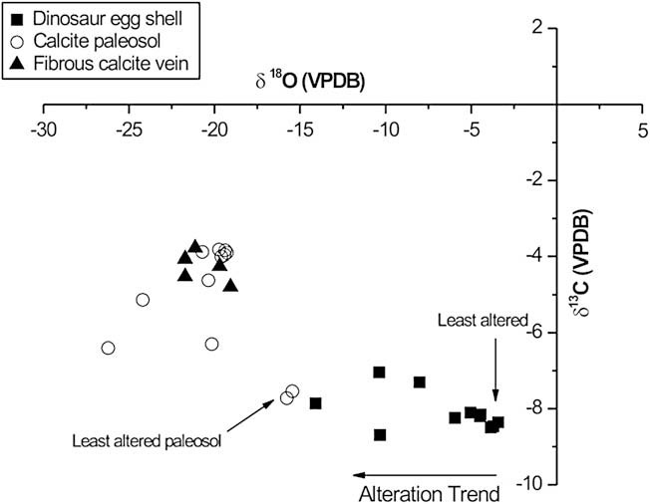**Figure 1.** A chart from an article written by Kim in 2007. The cross-pot shows the data of eggshells that were analyzed by Kim and colleagues from the same location as the one analyzed in this research. I use this as a reference to compare my data. The main thing is to look at the eggshells that they believe is least altered.

**3. Diagenesis and Solid-State Diffusion**

Anytime someone works with fossils there is always concerned with diagenesis. Diagenesis occurs when the fossil recrystallizes and gets the chemical composition of the sediment is buried in. There are different levels of diagenesis. In some cases, little alteration occurs, where the δ13C and δ18O values are changed but do not match the values of the surrounding. The other one is complete diagenesis, where the chemical composition is the same as the soil. The problem is that there is no method in determining whether diagenesis has occurred. As a reference figure 2 has been used to tell for possible alterations. The information is not trivial, but it gives a decent range to start the process of telling whether a sample is well preserved or altered.

When dealing with clumped isotope thermometry, one must also consider solid-state diffusion. Unlike diagenesis, which is an open system alteration, solid-state diffusion occurs in a closed system (Dennis 2010). In other words, the ordering of the heavy rare isotopes can be altered without having to change the composition of the fossil. This alteration can yield true δ13C and δ18O values, however the temperature from the ∆47 will change. Solid-state diffusion can occur when the sample is heated to high temperature that it will change the ordering of the molecules.

In order to decrease the chances of diagenesis, scientists use teeth enamel and eggshells because the crystals are large and densely packed, reducing the surface area making is more difficult for any diagenetic fluid to interact (Fricke 2014). More importantly, the oxygen readings from the phosphate in enamel show similar readings when analyzing the same taxa from two different localities.

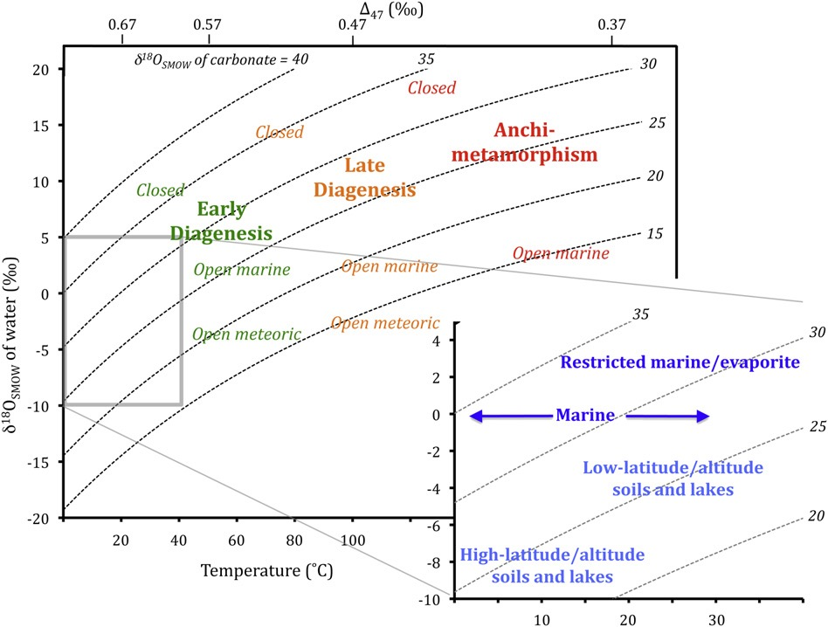**Figure 2.** Copied from a published paper by John Eiler, this cross plot of ∆47 vs. δ18O The plot gives a probable explanation for data that fall under certain regions.

**4. Analytical Method**

This research consisted of six eggshells, three samples of soil calcites, and a spinosaurus tooth. Due to a lack of time, I was not able to fully prep the tooth, but I was able to scrape off most plenty of fragments of tooth enamel. In order to remove the enamel, I first used a small drill to drill a hole in the dentin, as close to the enamel. I drilled a hole, a little bit larger than the size of the drill tip, and then I stuck the tweezers in the hole and cracked off the enamel.

The dinosaur eggshells where prepared a little differently. There were four unknown eggshells from Korea (B-E in figure 3). Also from Korea, there is an eggshell that is believed to be from a titanosaur (A in figure 3), which is twice as thick as the other eggshells (f in figure 3). In order to prepare all the samples, I first removed the outer layer of the eggshells. Since that is the layer that was in contact with the soil, I hoped that if any diagenesis occurred, it would only be on the outside layer. Thus, I shaved the outer layer by lightly sweeping a drill on the top layer. Using a mortar and pestle, I grinded the eggshells. For the calcites, all I did was grind the three sample.

During the analysis, there where problems with the mass spectrometer. At first the lab thought it was a weighting problem. After resubmitting larger sample sizes there was a similar problem. The lab found the problem with the mass spectrometer and I then submitted a third sample to be analyzed. When the problem first arrived, I also prepared and analyzed an eggshell from Argentina because other fragments 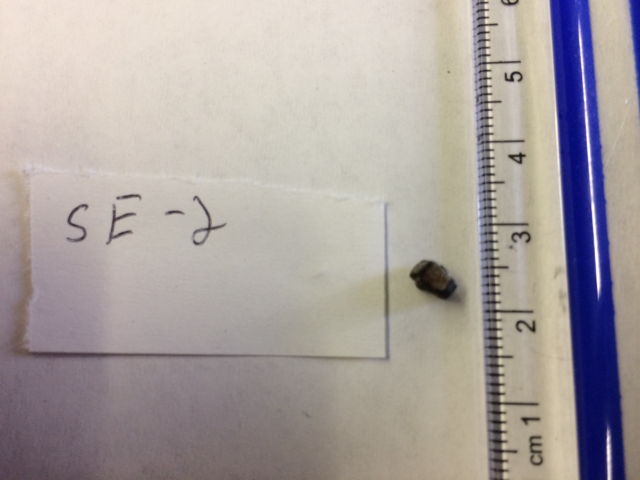of the eggshell have yielded good data.

B

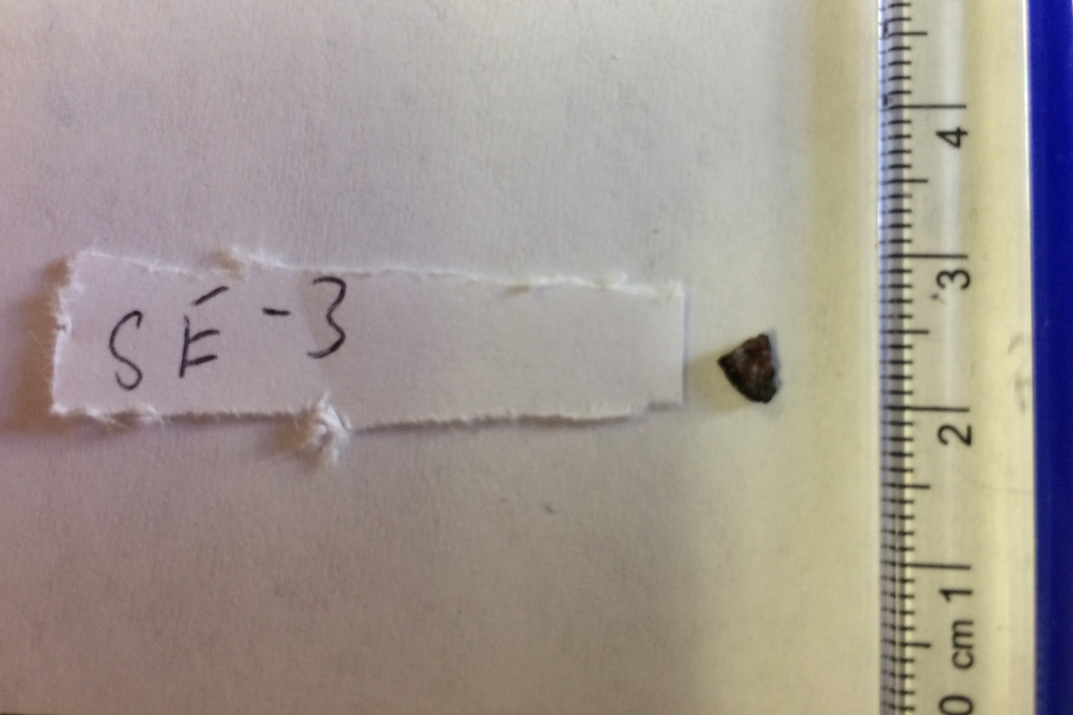

A

D

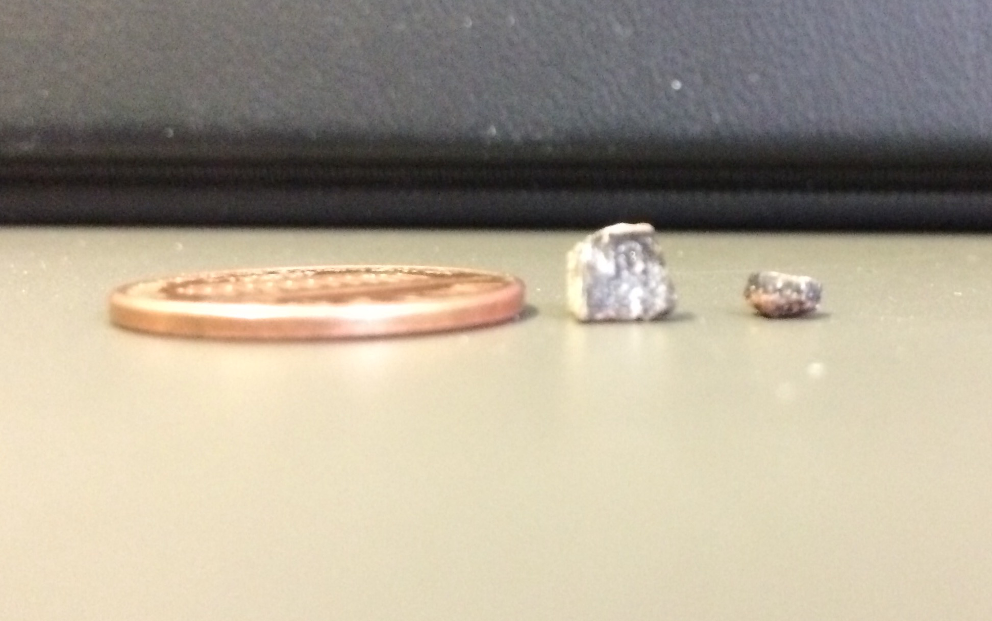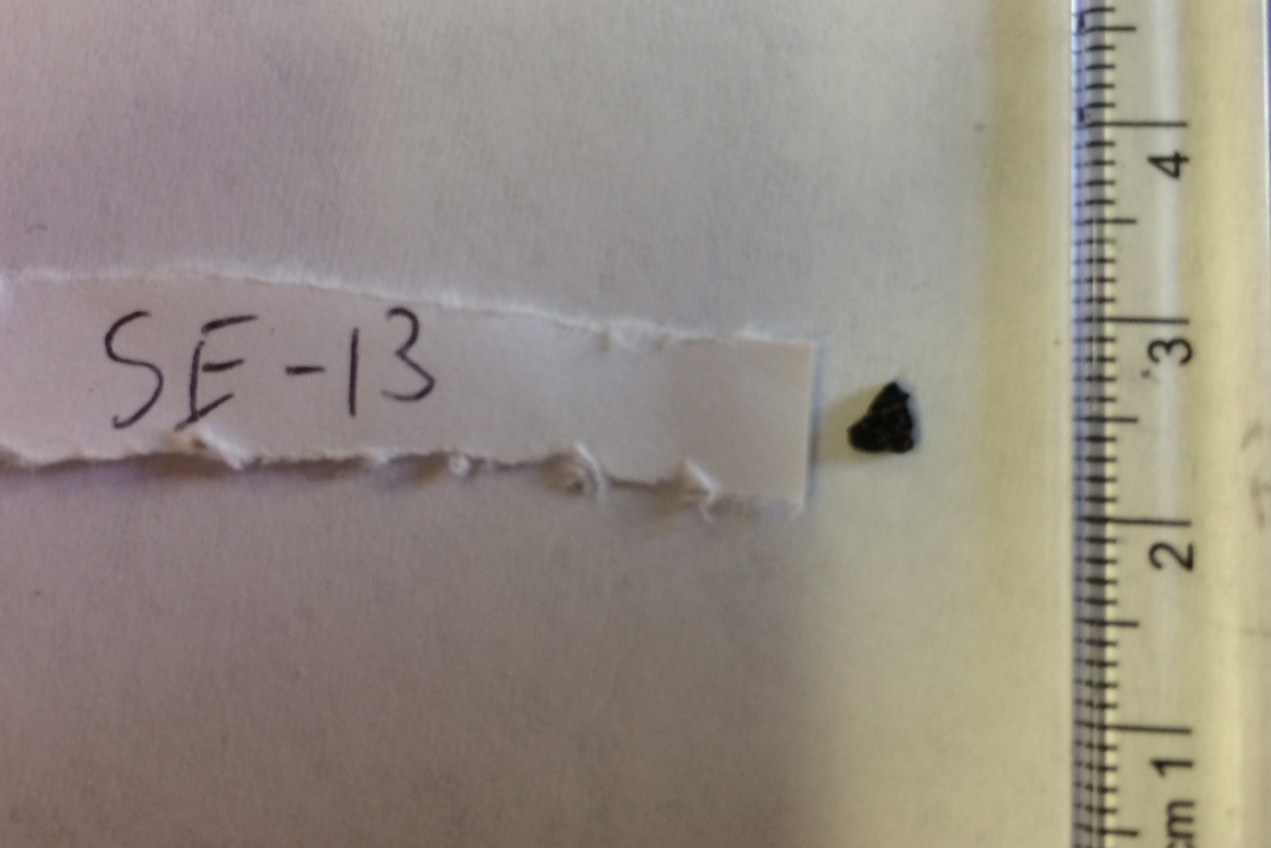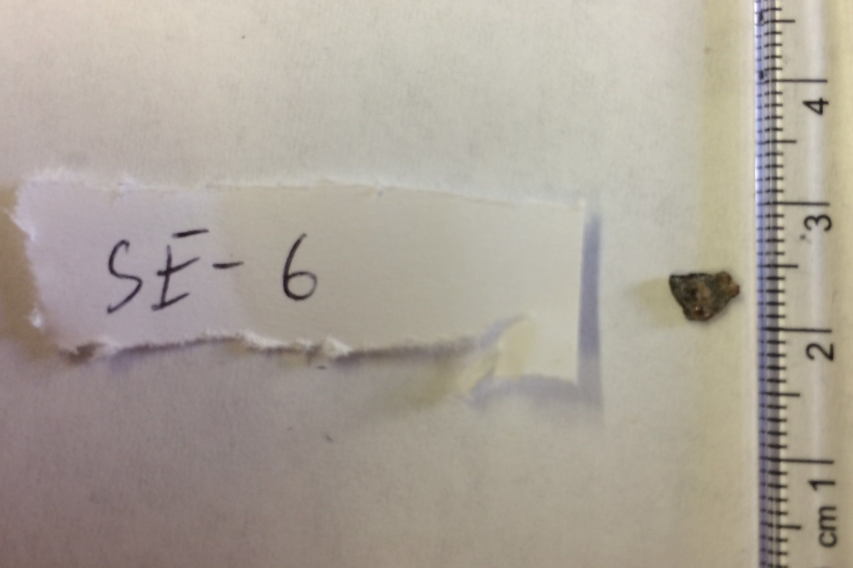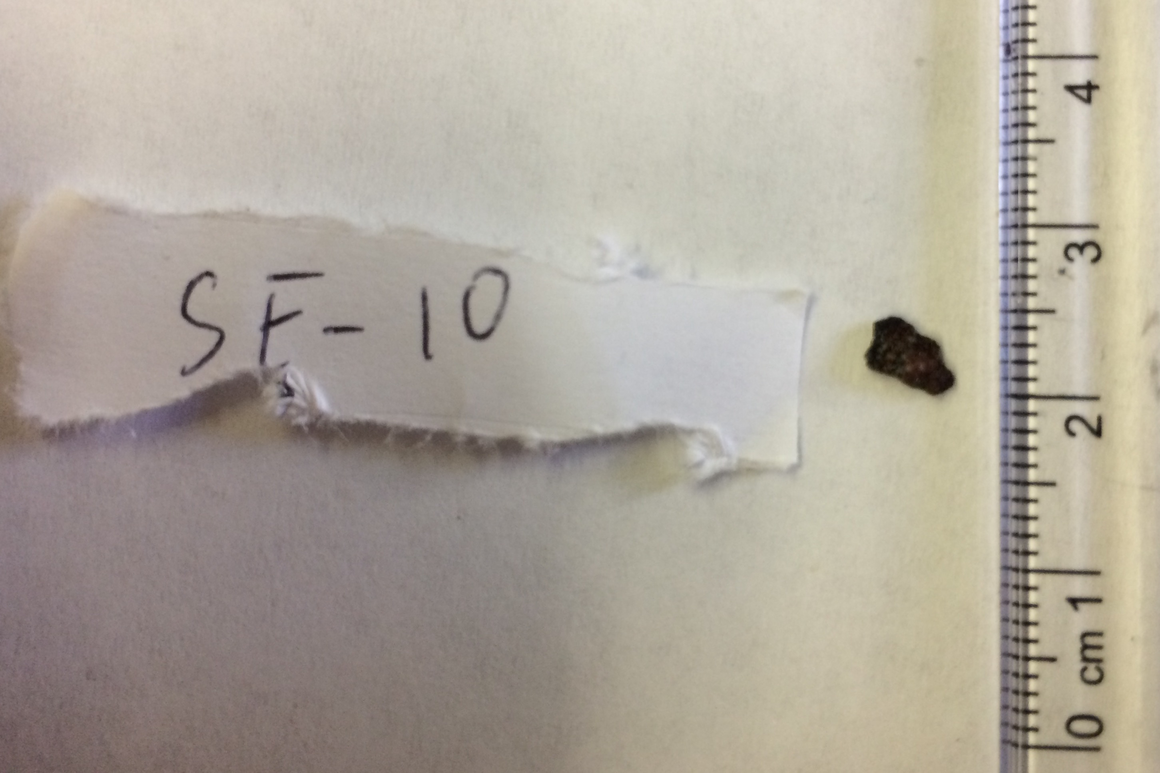

F

E

C

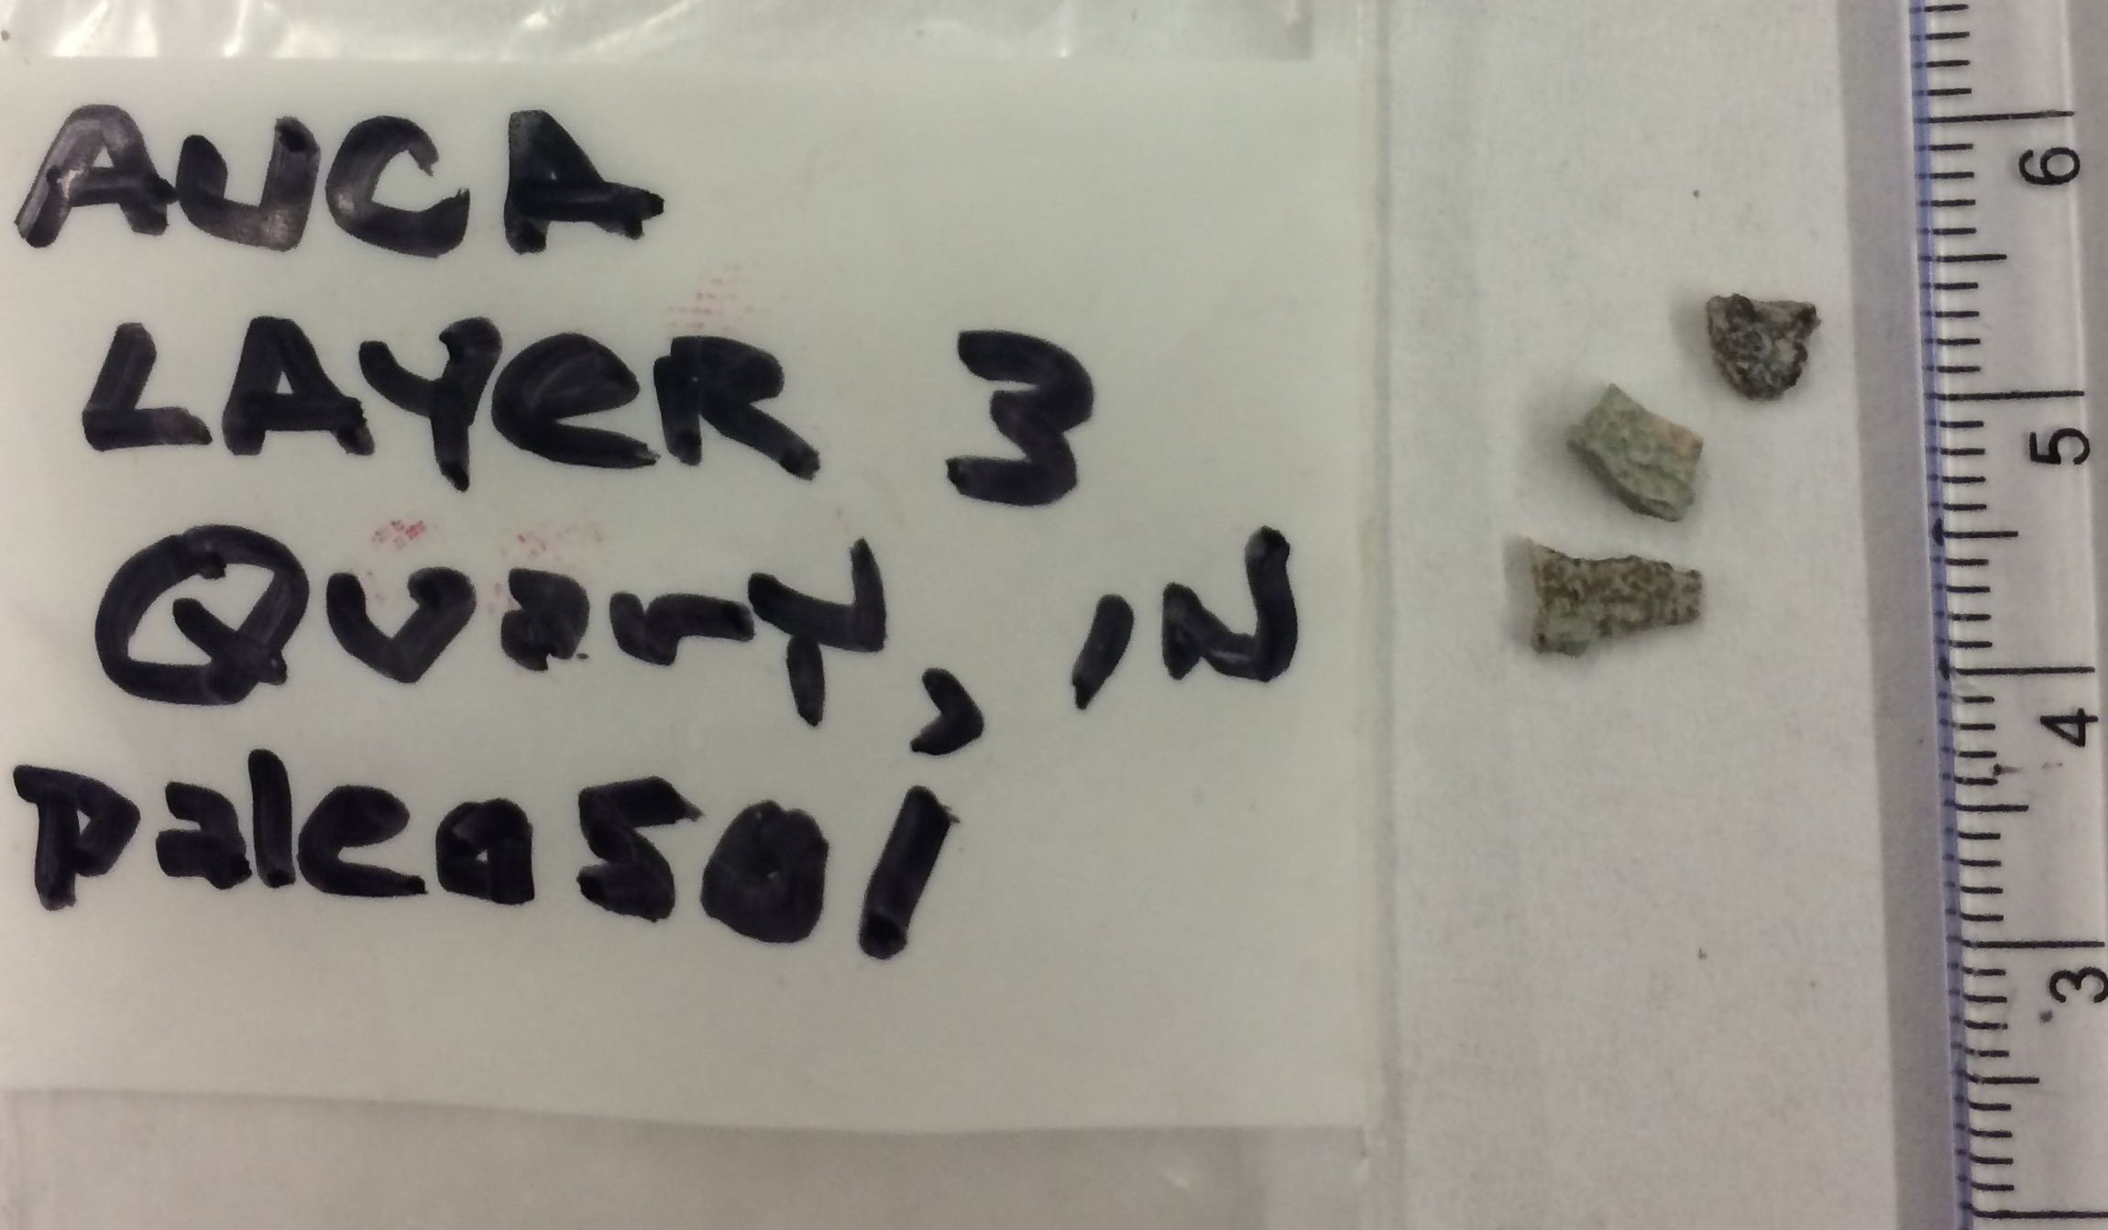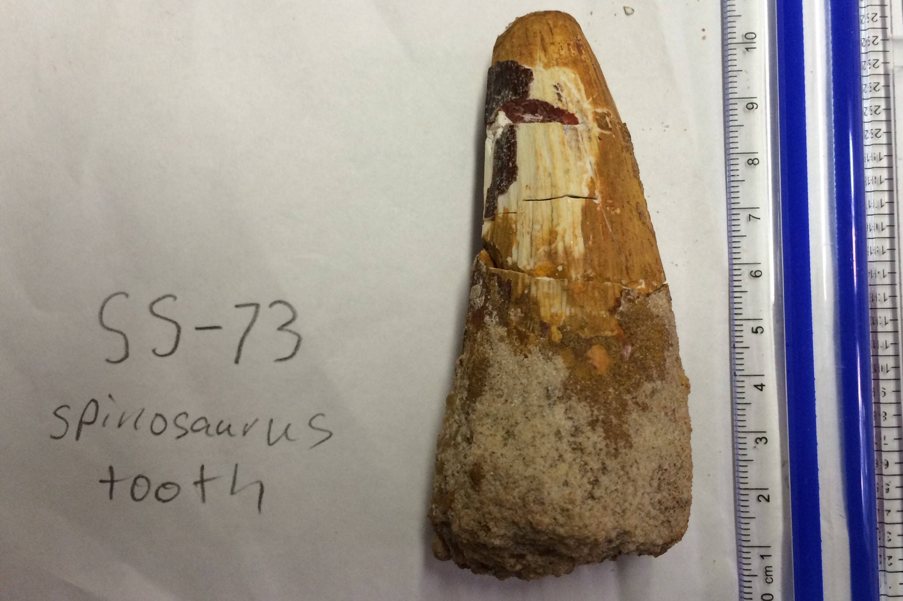

H

G

**Figure 3.** A) A titanosaur eggshell. B-E) Eggshells that are from an unknown species. Might come from the same species. F) A side shot of the titanosaur eggshell with one of the unknown with a penny as a scale. G) A dinosaur eggshell from Argentina. H) a spinosaurous tooth.

**Table 1- Data from the Samples**

|  |  |  |  |  |  |  |
| --- | --- | --- | --- | --- | --- | --- |
| **Sample** | **Sample** | **13C** | **18O** | **18O** | **47** | **18O** |
| **Type** | **ID** | **(PDB)** | **gas (SMOW)** | **calcite (PDB)** | **Temp (deg C)** | **Water (VSMOW)** |
|  |  |  |  |  |  |  |
| Soil | SH-42 | -0.869 | 20.288 | -18.315 | 106.1 | -3.2 |
| Soil | SH-44 | -5.225 | 24.653 | -14.116 | 61.7 | -5.2 |
| Soil | SH-45 | -1.134 | 21.834 | -16.828 | 100.3 | -2.4 |
|  |  |  |  |  |  |  |
| Titanosaur Eggshell | SE-10 | -7.204 | 28.151 | -10.75 | 95.1 | 3 |
| Unknown Eggshells | SE-13 | -6.977 | 27.157 | -11.706 | 87.6 | 1.1 |
| Unknown Eggshells | SE-6 | -6.631 | 28.36 | -10.548 | 93 | 3 |
| Unknown Eggshells | SE-3 | -6.8 | 27.072 | -11.788 | 122.2 | 5.4 |
| Unknown Eggshells | SE-2 | -5.015 | 29.662 | -9.296 | 111.6 | 6.6 |
|  |  |  |  |  |  |  |
| Argentina Eggshell | AL-3 | -12.676 | 37.585 | -1.673 | 35 | 2.6 |

**A**

**B**

**Figure 4** Plots A-C are different plots of my data. Plot D focuses on the four unknown eggshells, the titanosaur eggshell, the soil calcites, and data from Kim’s paper (4).

**D**

**5. Discussion**

The overall goal of the analysis was that the eggshells would be well preserved and could get a good possible temperature of the eggshell when it was created. Therefore, it will reflect the internal temperature of the dinosaur.

The very high temperature that was yielded by the ∆47 indicates that the eggshells were altered. There are two possible explanations: The first is that the eggshells have gone through diagenesis. The titanosaur eggshell shows the most signs of late diagenesis according to figure 2. Comparing it to the other eggshells, the titanosaur look like it is approaching the marble, which is as a standard. However, the composition of the eggshells do not match the composition of the soil carbonate. The titanosaur eggshell is actually the farthest, region wise, to the calcites.

In a complete diagenesis, an eggshell should have a similar composition of the soil calcites. The fact that in figure 4, the eggshells do not lay in a region that is close to the soil calcites suggest that diagenesis is not the most probable form of alteration.

Comparing the eggshells in this research to Kim’s data (fig 1/4D), the samples give similar data. Using Kim’s assumption of what eggshells are least altered; my samples have gone through some δ13C and δ18O alteration. Even though it is possible that the slight alterations could cause the high temperatures reading, it is more likely that the eggshells have gone through solid-state re-ordering. The low δ18O for the pedogenic calcites reinsure that hot hydrothermal fluid might have prevailed (Kim, Al-Aasm, Ghazban, and Chang 2007). With plenty of volcanic sediment in the soil, it is possible that some lava flowed over it at a close distance heating the eggshells enough to cause solid-state re-ordering.

**6. Conclusion**

What started as research that can add data on whether dinosaurs were endothermic or ectothermic turned into thinking what kind of alteration did the eggshells undergo. The high, impossible body temperature, ∆47 temperatures show that the eggshells have gone though alteration. Because the δ13C and δ18O of all the eggshells are in a region separated from the soil analyzed, it leads to the conclusion that the high temperatures are caused by solid-state diffusion.

**Reference**

(1) Dennis, Kate J., and Daniel P Schrag. "Clumped Isotope Thermometry of Carbonatites as an Indicator of Diagenetic Alteration." *ScienceDirect* (2010): 4110-122. Print

(2) Eagle, Robert A, Thomas Tütken, Taylor S. Martin, Aradhna K. Tripati, Henry C. Eiler, John M. "Paleoclimate Reconstruction Using Carbonate Clumped Isotope Thermometry." *Quaternary Science Reviews* (2011). Print.

(3) Fricke, Melissa Connely,, Richard L. Cifelli, and John M Eiler. "Dinosaur Body Temperatures Determined from Isotopic (13C-18O) Ordering in Fossil Biominerals." *Science Magazine* 23 Aug. 2013. Web.

(4) Kim, Cheong-Bin, Ihsan S. Al-Aasm, Fereydoun Ghazban, and Ho-Wan Chang. "Stable Isotopic Composition of Dinosaur Eggshells and Pedogenic Carbonates in the Upper Cretaceous Seonso Formation, South Korea: Paleoenvironmental and Diagenetic Implications." *Cretaceous Research* (2007). Print.

(5) Paik, In Sung, Min Huh, and Hyun Joo Kim. "Dinosaur Egg-bearing Deposits (Upper Cretaceous) of Boseong, Korea: Occurrence, Palaeoenvironments, Taphonomy, and Preservation." *Science Direct* (2003). *Elsevier*. Web.